2026 FALL SEMESTER
Programming for Data Science Lab (MACSE502) Record
INDEX
Week No | Date | Sl.  No. | Type | Topic | Title with download Link for document | Problem Statement | Page No.
1 | 09-07-  2026 | 1 | PP | Pandas | Basic Data Manipulation with Pandas | Create a DataFrame with columns Name, Age, and City containing data for five individuals. Perform the following operations: select only the Name and Age columns, filter rows where Age is greater than 25, add a new column Country with a default value, and sort the DataFrame by Age in descending order. Finally, calculate the average age of the  individuals. | 1
1 | 09-07-  2026 | 2 | EP | Pandas | AI Model Performance Analysis Using Pandas | An AI company maintains model performance records containing:  - ModelID  - Accuracy  - Algorithm Perform:  - Select ModelID and Accuracy.  - Filter models with Accuracy greater than 90%.  - Add Status with default value "Production Ready".  - Sort models by Accuracy.  - Calculate average model accuracy. | 6

PP: Practice Program; EP: Exercise Program; CP: Challenging Program

2026 FALL SEMESTER

Programming for Data Science Lab (MACSE502) Record Practice Program
Date: 09/07/2026 Week No.: 1 Program S. No. 1
Name | Age | City
Alice | 23 | New York
Bob | 30 | London
Charlie | 28 | Paris
David | 35 | Tokyo
Emma | 22 | Sydney

Title | Data Manipulation and Analysis using the Starwars Dataset in R
Problem Statement | Basic Data Manipulation with Pandas: Create a DataFrame with columns Name, Age, and City containing data for five individuals. Perform the following operations: select only the Name and Age columns, filter rows where Age is greater than 25, add a new column Country with a default value, and sort the DataFrame by Age in descending order. Finally, calculate the average age of the individuals.
Objectives | - To understand how to create a Pandas DataFrame from a Python  - dictionary.  - To learn column selection techniques using Pandas.  - To apply filtering conditions on DataFrame rows.  - To create and populate new columns in a DataFrame.  - To sort data based on column values.  - To perform basic statistical analysis using Pandas aggregate functions.
Dataset URL Link / File
Functions Details | Sl.  No. | Function | Package | Description of function
 | 1 | DataFrame() | pandas | Creates a DataFrame
 | 2 | sort_values() | pandas | Sorts DataFrame rows
 | 3 | mean() | pandas | Calculates the average value
 | 4 | sort_values() | pandas | Sorts DataFrame rows
Steps/ Process/ Procedure/ Algorithm/ Flowchart/ Model | Step 1  Import the pandas library and create a dictionary containing Name, Age and City Data  Step 2  Convert the dictionary into a pandas DataFrame  Step 3  Select only the Name and Age columns from the DataFrame.  Step 4  Filter the DataFrame to display individuals whose age is greater than 25.

Student Reg. No: 26MML0031 Name: Makada Hasnain Husainbhai
Faculty: Dr Rajasekhara Babu M, Professor, School of CSE, Vellore Institute of Technology (VIT), Vellore
1 | P a g e

2026 FALL SEMESTER

Programming for Data Science Lab (MACSE502) Record Practice Program
Date: 09/07/2026 Week No.: 1 Program S. No. 1
Step 5
Add a new column named Country and assign a default value of India.
Step 6
Sort the DataFrame in descending order based on the Age column.
Step 7
Calculate the average age of all individuals using the mean() function.
Step 8
– Display all intermediate and final results.
Program | # Load Necessary Packages import pandas as pd  # Step 1: Create Dataset dataframe1 = {  "Name": ["Alice", "Bob", "Charlie", "David", "Emma"], "Age": [23, 30, 28, 35, 22],  "City": ["New York", "London", "Paris", "Tokyo", "Sydney"]  }  # Step 2: Create DataFrame  df = pd.DataFrame(dataframe1)  print("Original DataFrame") print(df)  print()  # Step 3: Select Name and Age Columns name_age = df[["Name", "Age"]]  print("Name and Age") print(name_age) print()  # Step 4: Filter Rows where Age > 25 filtered_df = df[df["Age"] > 25]  print("Age > 25") print(filtered_df) print()
Student Reg. No: 26MML0031 Name: Makada Hasnain Husainbhai
Faculty: Dr Rajasekhara Babu M, Professor, School of CSE, Vellore Institute of Technology (VIT), Vellore
2 | P a g e

2026 FALL SEMESTER

Programming for Data Science Lab (MACSE502) Record Practice Program
Date: 09/07/2026 Week No.: 1 Program S. No. 1
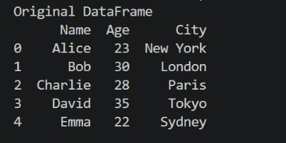
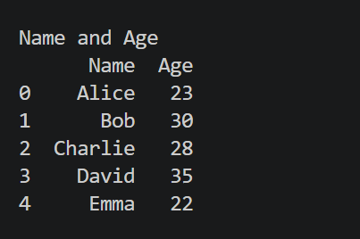
# Step 5: Add Country Column df["Country"] = "India"

print("Country Added") print(df)
print()

# Step 6: Sort by Age in Descending Order
sorted_df = df.sort_values(by="Age", ascending=False)

print("Sorted Data") print(sorted_df) print()

# Step 7: Calculate Mean Age mean_df = df["Age"].mean()

print("Mean Age") print(mean_df)

Figure 1.1 Original Dataframe
Figure 1.1 displays the original DataFrame created from a Python dictionary containing information about five individuals. The DataFrame consists of three columns: Name, Age, and City, where each row represents a different individual and their corresponding details. The pd.DataFrame() function converts

Output Snapshots With Explanation/ Observations
the dictionary data into a structured tabular format, making it easier to store, view, and manipulate data using Pandas. This DataFrame serves as the starting dataset for all subsequent operations such as column selection, filtering, adding new columns, sorting, and calculating statistical
measures.
Figure 1.2 shows the DataFrame after selecting only the Name and Age columns from the original dataset using Pandas column indexing. This operation extracts the required columns and creates a new DataFrame named name_age, removing the City column from the view. Such column selection helps focus on relevant attributes for analysis and reduces unnecessary data processing.
Figure 1.2 Selected Name and Age Columns

Student Reg. No: 26MML0031 Name: Makada Hasnain Husainbhai
Faculty: Dr Rajasekhara Babu M, Professor, School of CSE, Vellore Institute of Technology (VIT), Vellore
3 | P a g e

2026 FALL SEMESTER

Programming for Data Science Lab (MACSE502) Record Practice Program
Date: 09/07/2026 Week No.: 1 Program S. No. 1
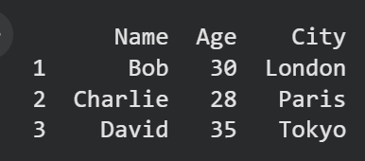
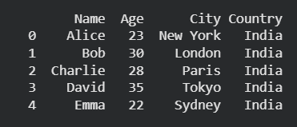
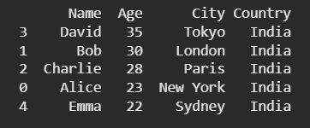
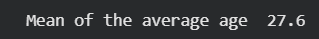
Figure 1.3 presents the filtered DataFrame containing only those individuals whose Age is greater than 25. This filtering operation is performed using a conditional expression in Pandas, where the Age
column is checked against the condition Age > 25. As a result, only the rows
Figure 1.3: Filtered Data (Age > 25)
satisfying the condition are retained in the new DataFrame filtered_df. Figure 1.3 operation demonstrates how Pandas can be used to extract specific records based on user-defined criteria, which is a common requirement in data analysis and data preprocessing tasks.

Figure 1.4 displays the DataFrame after adding a
new column named Country with a default value of "India" for all records. This operation is performed using Pandas column assignment, where the same value is assigned to
Figure 1.4: DataFrame with Country Column
every row in the newly created column. Adding new columns is a common data transformation technique used to enrich datasets with additional information. Figure 1.4 output confirms that the Country column has been successfully added to the DataFrame, and each individual has been assigned the default value India. The enriched dataset is now ready for further operations such as sorting and statistical analysis.

Figure 1.5 illustrates the DataFrame after sorting the records based on the Age column in descending order using the Pandas sort_values() function. In this operation, individuals are arranged from the highest age to the lowest age. Sorting helps organize data systematically and makes it easier to identify records with
Figure 1.5 Sorted Data by Age (Descending Order)
the largest or smallest values. Figure 1.5 output confirms that the DataFrame has been successfully sorted in descending order of Age, placing the oldest individual at the top and the youngest individual at the bottom. Such sorting operations are commonly used in data analysis to rank, compare, and organize records efficiently.

Figure 1.6 presents the average age of all individuals in the dataset, calculated using the Pandas mean() function. The average (mean) age is obtained by summing all the age values and dividing the total by the
Figure 1.6 Average Age of Individuals
number of individuals in the DataFrame. This operation demonstrates the use of aggregate statistical functions in Pandas for summarizing numerical data. Figure 1.6 output confirms that the Pandas mean() function has successfully computed the average age of the five individuals as 27.6 years. Such aggregate functions are widely used in
data analysis to summarize and interpret numerical information efficiently.
Student Reg. No: 26MML0031 Name: Makada Hasnain Husainbhai
Faculty: Dr Rajasekhara Babu M, Professor, School of CSE, Vellore Institute of Technology (VIT), Vellore
4 | P a g e

2026 FALL SEMESTER

Programming for Data Science Lab (MACSE502) Record Practice Program
Date: 09/07/2026 Week No.: 1 Program S. No. 1
Conclusions | This experiment successfully demonstrated the use of Pandas for basic data manipulation and analysis. A DataFrame containing the details of five individuals was created using the columns Name, Age, and City. Various DataFrame operations were then performed, including selecting specific columns, filtering rows based on a condition, adding a new column with default values, sorting records, and calculating statistical measures. These operations showcased the flexibility and efficiency of Pandas in handling tabular data.  The results showed that:  - The Name and Age columns could be extracted independently for focused analysis.  - Filtering enabled the identification of individuals whose Age was greater than 25 years.  - A new Country column was successfully added to enrich the dataset.  - Sorting arranged the records in descending order of age, making it easy to identify the oldest and youngest individuals.  - The average age of the individuals was calculated as 27.6 years, demonstrating the use of aggregate functions in data analysis.  Overall, this exercise provided a strong foundation in DataFrame creation, data selection, filtering, transformation, sorting, and statistical analysis using Pandas. These fundamental data manipulation techniques are widely used in Data Science, Machine Learning, Data Analytics, and Business Intelligence applications, making them essential skills for working with real-world datasets.
References | - Michael Freeman and Joel Ross, Programming Skills for Data Science: Start Writing Code to Wrangle, Analyze, and Visualize Data with R, Addison-Wesley, 2018  - Pandas Documentation: https://pandas.pydata.org/docs/  - Python Documentation: https://docs.python.org/3/  - Python Program (Google Colab link /Githab link) https://colab.research.google.com/drive/1sjdIVacPTNg2JO_nGS8gic 99hGEtMuRe?usp=sharing  - Class lecture link https://drive.google.com/file/d/15diEukCtrPLimox63oa9ce1U-t4qVMUy/view

Student Reg. No: 26MML0031 Name: Makada Hasnain Husainbhai
Faculty: Dr Rajasekhara Babu M, Professor, School of CSE, Vellore Institute of Technology (VIT), Vellore
5 | P a g e

2025 WINTER SEMESTER

Programming for Data Science Lab (MACSE502) Record Exercise Program
Date: 09/07/2026 Week No.: 1 Program S. No. 2
Title | Data Manipulation and Analysis using the Starwars Dataset in R
Problem Statement | An AI company maintains model performance records containing:  - ModelID  - Accuracy  - Algorithm Perform:  - Select ModelID and Accuracy.  - Filter models with Accuracy greater than 90%.  - Add Status with default value "Production Ready".  - Sort models by Accuracy.  - Calculate average model accuracy.
Objectives | - Understand how AI model performance data is stored and represented in a Pandas DataFrame.  - Filter machine learning models based on conditions, such as accuracy greater than 90%.  - Learn how to select specific columns such as ModelID and Accuracy.  - Sort AI models according to their accuracy values.  - Calculate statistical values such as average, minimum, and maximum model accuracy.  - Rank machine learning models based on their performance.
Dataset URL Link / File |  | ModelID |  | Algorithm |  |  | PreviousAccuracy | Accuracy
 |  | M101 |  | Logistic Regression |  |  | 84.5 | 87.2
 |  | M102 |  | Decision Tree |  |  | 87.0 | 89.5
 |  | M103 |  | Random Forest |  |  | 90.2 | 93.8
 |  | M104 |  | Support Vector Machine |  |  | 88.5 | 91.4
 |  | M105 |  | K-Nearest Neighbors |  |  | 82.5 | 85.6
 |  | M106 |  | Random Forest |  |  | 91.0 | 94.5
 |  | M107 |  | Decision Tree |  |  | 85.5 | 88.3
 |  | M108 |  | Neural Network |  |  | 92.0 | 96.1
 |  | M109 |  | Logistic Regression |  |  | 86.0 | 90.8
 |  | M110 |  | Neural Network |  |  | 93.1 | 95.4
 |  | M111 |  | Gradient Boosting |  |  | 89.4 | 92.7
 |  | M112 |  | Gradient Boosting |  |  | 91.8 | 94.1
Functions Details | Sl.  No. |  | Function |  | Package | Description of function
 | 1 |  | pd.DataFram e() |  | Pandas | Creates a DataFrame from the AI model data dictionary.
 | 2 |  | pd.read_csv() |  | Pandas | Reads AI model records from a CSV file.
 | 3 |  | dropna() |  | Pandas | Removes rows containing missing or invalid values
 | 4 |  | drop_duplicat es() |  | Pandas | Removes duplicate records based on ModelID.

Student Reg. No: 26MML0031 Name: Hasnain Makada

Faculty: Dr Rajasekhara Babu M, Professor, School of CSE, Vellore Institute of Technology (VIT), Vellore
6 | P a g e

2025 WINTER SEMESTER

Programming for Data Science Lab (MACSE502) Record Exercise Program
Date: 09/07/2026 Week No.: 1 Program S. No. 2
 | 5 | sort_values() | Pandas | Sorts the models according to their accuracy values.
 | 6 | mean() | Pandas | Calculates the average accuracy of all AI models.
 | 7 | groupby() and agg() | Pandas | Groups models by algorithm and calculates performance statistics.
 | 8 | to_csv() | Pandas | Saves the analysed model results into a CSV file.
Steps/ Process/ Procedure/ Algorithm/ Flowchart/ Model | - Import the Pandas package.  - Create the AI model dataset containing ModelID, Algorithm, PreviousAccuracy and Accuracy.  - Convert the dataset into a Pandas DataFrame.  - Clean the dataset by removing missing values, duplicate ModelIDs and invalid accuracy values.  - Select only the ModelID and Accuracy columns.  - Filter the models whose Accuracy is greater than 90%.  - Add a Status column with the default value “Production Ready”.  - Change the status to “Needs Improvement” for models having Accuracy below 90%.  - Sort the models in descending order based on Accuracy.  - Assign ranks to the models, where the highest-accuracy model receives Rank 1.  - Calculate the improvement of each model using:  Improvement = Accuracy − PreviousAccuracy  - Calculate the average accuracy of all models.  - Group the models by Algorithm and calculate minimum, maximum and average accuracy.  - Identify the best-performing, lowest-performing and most-improved models.  - Display all the analysis results in the console.  - Generate an automated model evaluation report.  - Save the analysed results in a CSV file and the report in a text file.
Program | import sys  from pathlib import Path import pandas as pd  from analysis_core import ( analyse_models, clean_data, create_algorithm_summary, create_report, create_sample_data, perform_basic_operations  )

Student Reg. No: 26MML0031 Name: Hasnain Makada

Faculty: Dr Rajasekhara Babu M, Professor, School of CSE, Vellore Institute of Technology (VIT), Vellore
7 | P a g e

2025 WINTER SEMESTER

Programming for Data Science Lab (MACSE502) Record Exercise Program
Date: 09/07/2026 Week No.: 1 Program S. No. 2
#
====================================================
========
# HEADING FUNCTION
# This keeps console output neat and readable. #
====================================================
========
def print_heading(title): print("\n" + "=" * 72) print(title)
print("=" * 72)
#
====================================================
========
# MAIN CONSOLE PROGRAM #
# Run with sample data:
# python console_app.py #
# Run with CSV data:
# python console_app.py sample_ai_models.csv #
====================================================
========
def main():
print_heading("AI MODEL PERFORMANCE ANALYSIS - CONSOLE MODE")
csv_file = None
# If the user gives a file path, use that CSV. if len(sys.argv) > 1:
csv_file = sys.argv[1]
if csv_file:
csv_path = Path(csv_file)
if not csv_path.exists():
print(f"Error: File not found: {csv_path}") return
print(f"Using CSV file: {csv_path}") raw_data = pd.read_csv(csv_path)
else:
print("Using built-in sample data.")

Student Reg. No: 26MML0031 Name: Hasnain Makada

Faculty: Dr Rajasekhara Babu M, Professor, School of CSE, Vellore Institute of Technology (VIT), Vellore
8 | P a g e

2025 WINTER SEMESTER

Programming for Data Science Lab (MACSE502) Record Exercise Program
Date: 09/07/2026 Week No.: 1 Program S. No. 2
raw_data = create_sample_data()
try:
cleaned_data = clean_data(raw_data) except ValueError as error:
print(f"Data error: {error}") return
analysed_data = analyse_models( cleaned_data, production_threshold=90.0
)
results = perform_basic_operations( analysed_data
)
print_heading("ORIGINAL CLEANED DATA") print(
cleaned_data.to_string(index=False)
)
print_heading("1. SELECT MODELID AND ACCURACY") print(
results["selected_columns"]
.to_string(index=False)
)
print_heading(
"2. FILTER MODELS WITH ACCURACY GREATER THAN 90%"
)
print(
results["models_above_90"][ ["ModelID", "Algorithm", "Accuracy"]
].to_string(index=False)
)
print_heading(
'3. ADD STATUS WITH DEFAULT "PRODUCTION READY"'
)
print(
results["status_table"]
.to_string(index=False)
)
print_heading("4. SORT MODELS BY ACCURACY") print(

Student Reg. No: 26MML0031 Name: Hasnain Makada

Faculty: Dr Rajasekhara Babu M, Professor, School of CSE, Vellore Institute of Technology (VIT), Vellore
9 | P a g e

2025 WINTER SEMESTER

Programming for Data Science Lab (MACSE502) Record Exercise Program
Date: 09/07/2026 Week No.: 1 Program S. No. 2
results["sorted_models"][
["ModelID", "Algorithm", "Accuracy"]
].to_string(index=False)
)
print_heading("5. CALCULATE AVERAGE MODEL ACCURACY")
print(
f'Average model accuracy: ' f'{results["average_accuracy"]:.2f}%'
)
print_heading("MODEL RANKING") print(
analysed_data[ [
"Rank", "ModelID", "Algorithm",
"PreviousAccuracy", "Accuracy", "Improvement", "Status"
]
].to_string(index=False)
)
print_heading("ALGORITHM PERFORMANCE COMPARISON")
algorithm_summary = create_algorithm_summary( analysed_data
)
print(
algorithm_summary.to_string(index=False)
)
print_heading("ACCURACY IMPROVEMENT TRACKING")
print(
analysed_data[ [
"ModelID", "PreviousAccuracy", "Accuracy", "Improvement", "ImprovementStatus"
]
].to_string(index=False)
)

Student Reg. No: 26MML0031 Name: Hasnain Makada

Faculty: Dr Rajasekhara Babu M, Professor, School of CSE, Vellore Institute of Technology (VIT), Vellore
10 | P a g e

2025 WINTER SEMESTER

Programming for Data Science Lab (MACSE502) Record Exercise Program
Date: 09/07/2026 Week No.: 1 Program S. No. 2
report = create_report( analysed_data, production_threshold=90.0
)
print_heading("AUTOMATED EVALUATION REPORT") print(report)
# Save analysed data. analysed_data.to_csv(
"console_ai_model_results.csv", index=False
)
# Save the report. with open(
"console_ai_model_report.txt", "w",
encoding="utf-8"
) as report_file: report_file.write(report)
print_heading("FILES CREATED") print("console_ai_model_results.csv") print("console_ai_model_report.txt")
if name == " main ": main()
Output Snapshots With Explanation/ Observations | The program successfully loaded and cleaned the AI model performance dataset. The dataset contained ModelID, Algorithm, PreviousAccuracy and Accuracy.  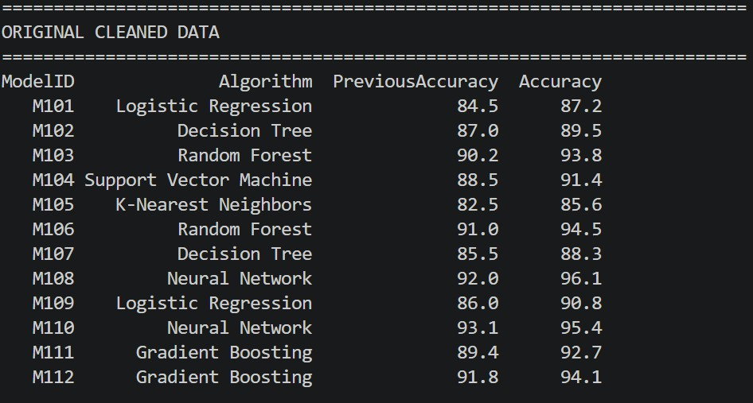  Figure 2.1 Original Cleaned Dataset  The ModelID and Accuracy columns were selected successfully. Models having accuracy greater than 90% were filtered from the dataset.  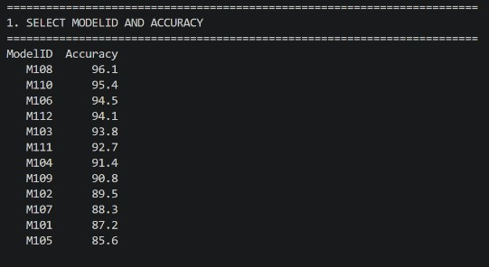  Figure 1.2 Selected ModelID and Accuracy

Student Reg. No: 26MML0031 Name: Hasnain Makada

Faculty: Dr Rajasekhara Babu M, Professor, School of CSE, Vellore Institute of Technology (VIT), Vellore
11 | P a g e

2025 WINTER SEMESTER
Programming for Data Science Lab (MACSE502) Record Exercise Program
Date: 09/07/2026 Week No.: 1 Program S. No. 2

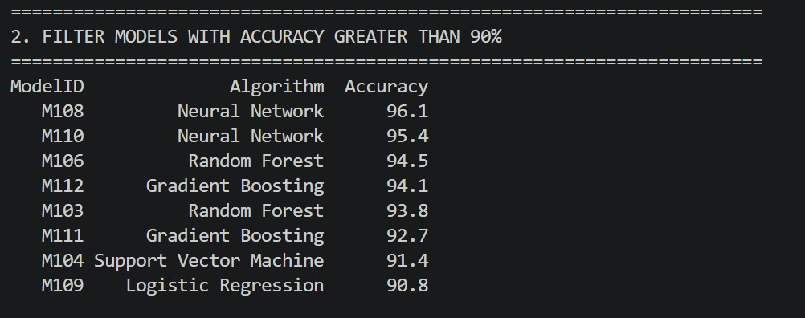
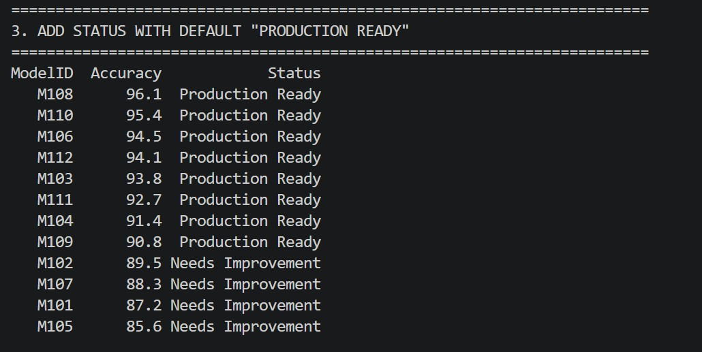
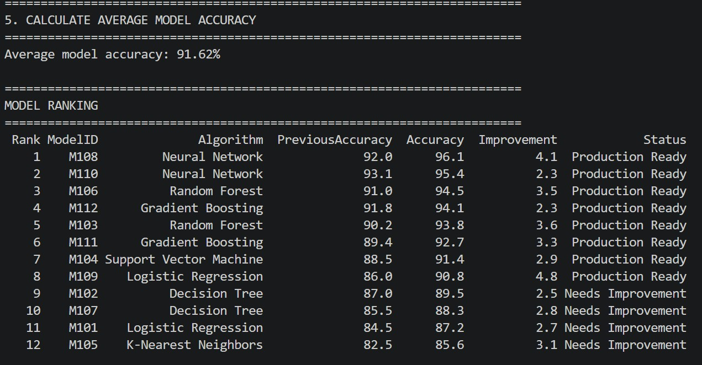
A Status column was added.
Figure 1.4 Status Column and Models sorted by accuracy
Figure 1.3 Models Accuracy Greater than 90%
Models with accuracy greater than or equal to 90% were marked as “Production Ready”, while the remaining
models were marked as “Needs Improvement”.

Figure 1.5 Average Model Accuracy

The average accuracy of all models was calculated.
Accuracy improvement was also calculated by subtracting PreviousAccuracy from the current Accuracy.

Student Reg. No: 26MML0031 Name: Hasnain Makada

Faculty: Dr Rajasekhara Babu M, Professor, School of CSE, Vellore Institute of Technology (VIT), Vellore
12 | P a g e

2025 WINTER SEMESTER

Programming for Data Science Lab (MACSE502) Record Exercise Program
Date: 09/07/2026 Week No.: 1 Program S. No. 2
 | 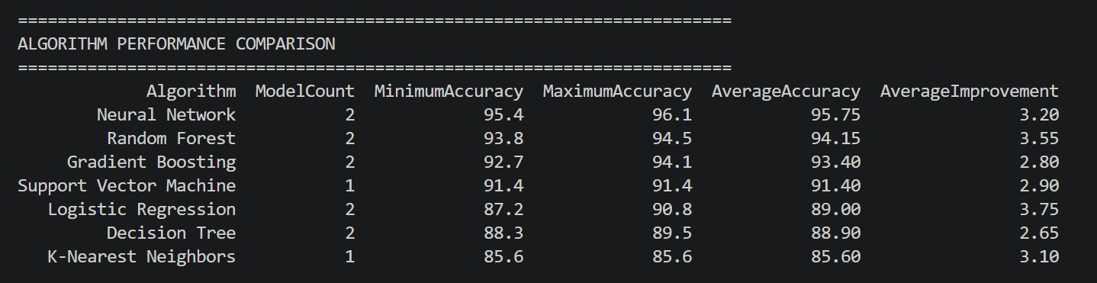
 | Figure 1.6 Models Grouped according to their algorithm and other metrics
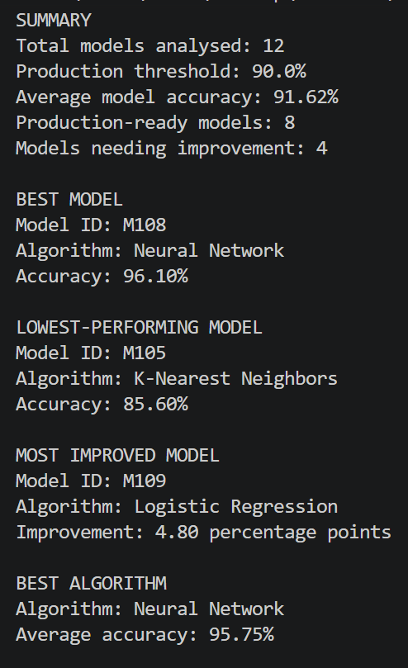
The models were grouped according to their algorithms, and minimum, maximum and average accuracy values were calculated for each
algorithm.

The program identified the best-performing model, lowest-performing model, most-improved model and best-performing algorithm.
 | Figure 1.7 Final Output
Conclusions | The exercise successfully demonstrated how Pandas can be used to analyse AI model performance data. The program selected, filtered, sorted and ranked the models, calculated average accuracy, compared algorithm performance and tracked accuracy improvement. It also generated an automated evaluation report and saved the final results in CSV and text formats.
References | - Michael Freeman and Joel Ross, Programming Skills for Data Science: Start Writing Code to Wrangle, Analyze, and Visualize Data with R, Addison-Wesley, 2018  - Python Program (https://github.com/hasnainmakada-99/Data-Science-Codes/blob/main/WEEK%201/Excercise_Program_Console.py)  - Class lecture link (https://drive.google.com/file/d/15diEukCtrPLimox63oa9ce1U-t4qVMUy/view?usp=drive_link)

Student Reg. No: 26MML0031 Name: Hasnain Makada

Faculty: Dr Rajasekhara Babu M, Professor, School of CSE, Vellore Institute of Technology (VIT), Vellore
13 | P a g e

2026 FALL SEMESTER

Programming for Data Science Lab (MACSE502) Record
INDEX
Week No | Date | Sl.  No. | Type | Topic | Title with download Link for document | Problem Statement | Page No.
1 | 09-07-  2026 | 1 | PP | Pandas | Basic Data Manipulation with Pandas | Create a DataFrame with columns Name, Age, and City containing data for five individuals. Perform the following operations: select only the Name and Age columns, filter rows where Age is greater than 25, add a new column Country with a default value, and sort the DataFrame by Age in descending order. Finally, calculate the average age of the  individuals. | 1
1 | 09-07-  2026 | 2 | EP | Pandas | AI Model Performance Analysis Using Pandas | An AI company maintains model performance records containing:  - ModelID  - Accuracy  - Algorithm Perform:  - Select ModelID and Accuracy.  - Filter models with Accuracy greater than 90%.  - Add Status with default value "Production Ready".  - Sort models by Accuracy.  Calculate average model accuracy. | 6
2 | 16-07-  2026 | 3 | PP | Pandas | Data Cleaning and Preprocessing with Pandas | Create a DataFrame with some missing values in columns Name, Age, and City. Perform the following operations: fill missing values in the Age column with the mean age, drop rows where Name or City is missing, and convert the Age column to integer type. Finally, normalize the Age column  using min-max scaling | 1
2 | 16-07-  2026 | 4 | EP | Pandas | Movie Rating Data Preprocessing Using Pandas | A streaming platform maintains movie records containing:  - MovieID  - Rating  - Genre Perform:  - Create a dataset with missing values.  - Fill missing Rating values using average rating.  - Remove rows with missing MovieID or Genre.  - Convert Rating into integer type.  - Normalize rating values. | 5
PP: Practice Program; EP: Exercise Program; CP: Challenging Program

2026 FALL SEMESTER
Programming for Data Science Lab (MACSE502) Record Practice Program
Date: 16/07/2026 Week No.: 2 Program S. No. 3
Title | Student Marks Data Manipulation and Analysis using Pandas
Problem Statement | Data Cleaning and Preprocessing with Pandas: Create a DataFrame with some missing values in columns Name, Age, and City. Perform the following operations: fill missing values in the Age column with the mean age, drop rows where Name or City is missing, and convert the Age column to integer type. Finally, normalize the Age column using min-max scaling.
Objectives | - To understand how to create a Pandas DataFrame containing missing values.  - To learn how to identify and handle missing data using the fillna()  function.  - To remove incomplete records using the dropna() function.  - To convert a DataFrame column to the required data type using the  astype() function.  - To normalize numerical data using the Min-Max Scaling technique.  To understand the importance of data preprocessing before performing data analysis and machine learning tasks.
Dataset URL Link / File
 |  |  | Name |  | Age |  | City
 |  |  | Arjun |  | np.nan |  | np.nan
 |  |  | Priya |  | 28 |  | Mumbai
 |  |  | Rohan |  | 35 |  | Delhi
 |  |  | Sneha |  | np.nan |  | np.nan
 |  |  | Amit |  | 40 |  | Bangalore
 |  |  | Deepa |  | 30 |  | Chennai
 |  |  | Rahul |  | np.nan |  | np.nan
 |  |  | np.nan |  | 33 |  | Kolkata
 |  |  | np.nan |  | 29 |  | Ahmedabad
Functions Details | Sl.  No. | Function |  | Package |  | Description of function
 | 1 | DataFrame() |  | pandas |  | Creates a DataFrame from structured data
 | 2 | Mean() |  | pandas |  | Calculates the average value
 | 3 | fillna() |  | pandas |  | Replaces missing values with a specified value.
 | 4 | dropna() |  | pandas |  | Removes rows containing missing values.

Student Reg. No: 26MML0031 Name: Makada Hasnain Husainbhai
Faculty: Dr Rajasekhara Babu M, Professor, School of CSE, Vellore Institute of Technology (VIT), Vellore
1 | P a g e

2026 FALL SEMESTER
Programming for Data Science Lab (MACSE502) Record Practice Program
Date: 16/07/2026 Week No.: 2 Program S. No. 3
Step 1
Import the pandas library.
Step 2
Create a Python dictionary containing StudentID, Name, and Marks for five students.
Steps/ Process/ Procedure/ Algorithm/ Flowchart/ Model | Step 3  Convert the dictionary into a Pandas DataFrame and display the original dataset.  Step 4  Select and display only the Name and Marks columns.  Step 5  Filter and display students whose Marks are greater than 70.  Step 6  Add a Grade column by assigning grades A to E according to the marks obtained.
Step 7
Display the updated DataFrame containing the Grade column.
Step 8
Sort the DataFrame by Marks in ascending order and display the result.
Step 9
Calculate and display the average marks using the mean() function.
 | # Import the Pandas library import pandas as pd
# Create a dictionary containing student details dictionary_1 = {
"StudentID": [10, 11, 12, 13, 14],
"Name": ["Hasnain", "John", "Alice", "Sahil", "Cook"], "Marks": [45, 86, 90, 67, 97]
}
 | # Convert the dictionary into a Pandas DataFrame dataFrame = pd.DataFrame(dictionary_1)
 | # Display the original dataset print("Diplaying the Original Dataset\n") print(dataFrame, "\n")
Program | # Select and display only the Name and Marks columns only_name_colum = pd.DataFrame(  dataFrame, columns=["Name", "Marks"]  )  print("Displaying only name and marks columns\n") print(only_name_colum, "\n")
# Filter students whose marks are greater than 70 marks_greater_than_70 = pd.DataFrame(
dataFrame[dataFrame["Marks"] > 70]
)
print("Displaying students with marks greater than 70\n") print(marks_greater_than_70, "\n")
# Assign grades based on the marks obtained dataFrame["Grade"] = [
"A" if marks >= 90 else "B" if marks >= 80 else "C" if marks >= 70 else "D" if marks >= 60 else "E"
for marks in dataFrame["Marks"]
Student Reg. No: 26MML0031 Name: Makada Hasnain Husainbhai
Faculty: Dr Rajasekhara Babu M, Professor, School of CSE, Vellore Institute of Technology (VIT), Vellore
2 | P a g e

2026 FALL SEMESTER
Programming for Data Science Lab (MACSE502) Record Practice Program
Date: 16/07/2026 Week No.: 2 Program S. No. 3
]

# Display the updated dataset with the Grade column print("Displaying the updated dataset\n") print(dataFrame, "\n")

# Sort the dataset by Marks in ascending order sort_by_marks = dataFrame.sort_values(
by="Marks", ascending=True
)
print("Displaying the sorted dataset\n") print(sort_by_marks, "\n")

# Calculate and display the average marks average = dataFrame["Marks"].mean() print("Average Marks \n")
print(average)
Figure 2.1 displays the original DataFrame created fr student dictionary. It contains the columns Stud Name, and Marks for five students. The pd.DataF function converts the dictionary into a structured format that can be analysed using Pandas.
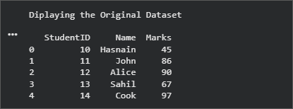
Figure 2.1 Original Student Dataset
2.2 shows only the Name and Marks columns selected the original DataFrame. This demonstrates column selection and allows the analysis to focus on the student names and their corresponding marks without Displaying StudentID.
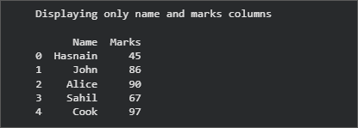
Figure 2.2 Selected Name and Marks Columns
Output Snapshots With Explanation/ Observations | 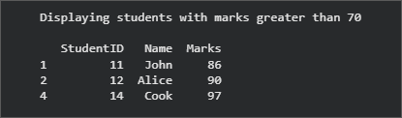  Figure 2.3 presents the filtered records for students Marks are greater than 70. The Boolean  condition dataFrame["Marks"] > 70 retains John, Alice, and Cook because their marks satisfy the specified condition.
Figure 2.3 Filtering student with marks
> 70
2.4 displays the updated DataFrame after the Grade column. Grades are assigned conditional logic: A for marks of 90 or B for 80-89, C for 70-79, D for 60-69, and marks below 60.
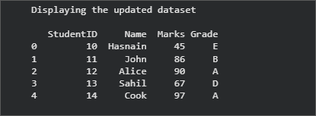
Figure 2.4 Dataset after Adding the Grade Column
Figure 2.5 shows the records sorted from the lowest to the highest marks using sort_values(). Hasnain appears first with 45 marks, while Cook appears
last with 97 marks. The original row indexes are retained by Pandas.
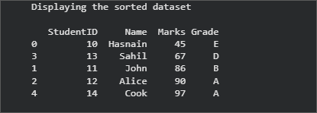
2.5 Dataset Sorted by Marks in Ascending Order

Student Reg. No: 26MML0031 Name: Makada Hasnain Husainbhai
Faculty: Dr Rajasekhara Babu M, Professor, School of CSE, Vellore Institute of Technology (VIT), Vellore
3 | P a g e

2026 FALL SEMESTER
Programming for Data Science Lab (MACSE502) Record Practice Program
Date: 16/07/2026 Week No.: 2 Program S. No. 3
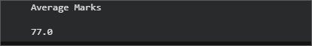
Figure 2.6 displays the average marks calculated by using mean() function. The total marks of all students divided by five gives an average
77.0. Figure 2.6 Average Marks
Conclusions | This exercise successfully demonstrated basic student-data manipulation and analysis using Pandas. A DataFrame containing StudentID, Name, and Marks was created from a Python dictionary, and multiple operations were performed on the dataset.  The results showed that:  - The Name and Marks columns were selected successfully for focused analysis.  - Students with marks greater than 70 were identified using Boolean filtering.  - A Grade column was generated using conditional logic based on each student's marks.  - The records were arranged in ascending order of marks using sort_values().  - The average marks of the five students were calculated as 77.0 using mean(). Overall, the exercise provided practical experience in DataFrame creation, column selection, row filtering, conditional transformation, sorting, and statistical  aggregation. These operations are fundamental for data preprocessing and exploratory  data analysis in Data Science and Machine Learning applications.
References | - Wes McKinney, Python for Data Analysis: Data Wrangling with pandas, NumPy, and Jupyter, 3rd Edition, O’Reilly Media, 2022.  - Pandas Documentation: https://pandas.pydata.org/docs/  - Python Documentation: https://docs.python.org/3/  - Python Program (Google Colab Link) https://colab.research.google.com/drive/1qBzvtH6ZEis8Jv20WDiYXKI4PXGSXcWJ?usp=sharing  - Pandas DataFrame API Reference: https://pandas.pydata.org/docs/reference/api/pandas.DataFrame.html  - Class lecture link: https://drive.google.com/file/d/15diEukCtrPLimox63oa9ce1U-t4qVMUy/view

Student Reg. No: 26MML0031 Name: Makada Hasnain Husainbhai
Faculty: Dr Rajasekhara Babu M, Professor, School of CSE, Vellore Institute of Technology (VIT), Vellore
4 | P a g e

2025 WINTER SEMESTER
Programming for Data Science Lab (MACSE502) Record Exercise Program
Date: 16/07/2026 Week No.: 2 Program S. No. 4
Title | Data Manipulation and Analysis using the Starwars Dataset in R
Problem Statement | A streaming platform maintains movie records containing:  - MovieID  - Rating  - Genre Perform:  - Create a dataset with missing values.  - Fill missing Rating values using average rating.  - Remove rows with missing MovieID or Genre.  - Convert Rating into integer type.  - Normalize rating values.
Objectives | - To understand movie data preprocessing using the Pandas library.  - To create a dataset containing missing values.  - To identify and handle missing values in a dataset.  - To fill missing Rating values using the average rating.  - To remove records with missing MovieID or Genre.  - To convert the Rating column into integer data type.  - To normalize movie rating values using Min-Max normalization.  - To identify top-rated movies based on ratings.
Dataset URL Link / File |  | MovieID | MovieTit le | Rating | Genre | ViewCou nt | Likes
 |  | MV101 | The Last  Horizon | 8.5 | Science  Fiction | 125000 | 11200
 |  | MV102 | City  Lights |  | Comedy | 98000 | 7500
 |  | MV103 | Hidden  Truth | 7.8 | Thriller | 110000 | 8900
 |  | None | Lost  Kingdom | 9.1 | Fantasy | 150000 | 13500
 |  | MV105 | Digital  Dreams | 8.9 | Science  Fiction | 175000 | 16000
 |  | MV106 | Silent  River |  | Drama | 87000 | 6100
 |  | MV107 | Future  Code | 9.3 | Science  Fiction | 210000 | 19800
 |  | MV108 | Broken  Compass | 6.7 |  | 65000 | 4200
 |  | MV109 | Midnight  Journey | 8.1 | Adventur  e | 132000 | 10400
 |  | MV110 | Laugh  Again | 7.5 | Comedy | 105000 | 8100
 |  | MV111 | Ocean  Mystery | 8.8 | Mystery | 143000 | 12100
 |  | MV112 | Final  Mission |  | Action | 190000 | 17400

Student Reg. No: 26MML0031 Name: Makada Hasnain H

Faculty: Dr Rajasekhara Babu M, Professor, School of CSE, Vellore Institute of Technology (VIT), Vellore
5 | P a g e

2025 WINTER SEMESTER
Programming for Data Science Lab (MACSE502) Record Exercise Program
Date: 16/07/2026 Week No.: 2 Program S. No. 4
 |  | MV113 |  | Parallel  Lives |  | 8.4 |  | Drama | 118000 | 9600
 |  | MV114 |  | Wild  Trails |  | 7.2 |  | Adventur  e | 99000 | 7200
 |  | MV115 |  | The Great  Escape |  | 9.0 |  | Action | 205000 | 18800
Functions Details | Sl.  No. |  | Function |  | Package |  | Description of function
 | 1 |  | pd.DataFram  e() |  | Pandas |  | Creates a DataFrame from the movie  dataset stored in dictionary format.
 | 2 |  | isnull() |  | Pandas |  | Identifies missing values present in the  movie dataset.
 | 3 |  | mean() |  | Pandas |  | Fills missing Rating values using the  calculated average rating.
 | 4 |  | dropna() |  | Pandas |  | Removes rows containing missing  MovieID or Genre values.
 | 5 |  | pd.to_numeri  c() |  | Pandas |  | Converts Rating values into numeric  format and handles invalid entries.
 | 6 |  | round() |  | Pandas |  | Rounds decimal Rating values before  converting them into integers.
 | 7 |  | astype() |  | Pandas |  | Converts the Rating column into integer  data type.
 | 8 |  | min() |  | Pandas |  | Finds the minimum Rating value  required for normalization.
 | 9 |  | max() |  | Pandas |  | Finds the maximum Rating value  required for normalization.
 | 10 |  | groupby() |  | Pandas |  | Groups movie records according to  Genre for genre-wise analysis.
 | 11 |  | sort_values() |  | Pandas |  | Sorts movies based on rating, popularity  score or number of views.
 | 12 |  | fillna() |  | Pandas |  | Fills missing Rating values using the  calculated average rating.
Steps/ Process/ Procedure/ Algorithm/ Flowchart/ Model | Step 1: Import the Pandas library and create the movie dataset in dictionary format.  Step 2: Convert the dictionary into a Pandas DataFrame using pd.DataFrame().  Step 3: Display the original dataset containing missing values.  Step 4: Calculate the average value of the Rating column using the mean() function.  Step 5: Fill the missing Rating values using fillna() with the calculated average rating.
Student Reg. No: 26MML0031 Name: Makada Hasnain H

Faculty: Dr Rajasekhara Babu M, Professor, School of CSE, Vellore Institute of Technology (VIT), Vellore
6 | P a g e

2025 WINTER SEMESTER
Programming for Data Science Lab (MACSE502) Record Exercise Program
Date: 16/07/2026 Week No.: 2 Program S. No. 4
Step 6: Remove rows containing missing MovieID or Genre using the dropna() function.
Step 7: Convert the Rating column into numeric format using pd.to_numeric() and then convert it into integer type using round() and astype(int).
Step 8: Normalize the Rating values using the Min-Max Normalization formula:
Normalized Rating = (Rating − Minimum Rating) / (Maximum Rating −
Minimum Rating)
Step 9: Calculate the Engagement Rate and Popularity Score for each movie based on views, likes and ratings.
Step 10: Sort the movies according to Popularity Score and Rating using sort_values() and assign popularity ranks.
Step 11: Generate a genre-wise report using the groupby() function to compare movie performance across different genres.
Step 12: Recommend the top movies based on selected genre and minimum rating, generate the automated analytics report, and save the processed results for future analysis.
 | import pandas as pd
 | #
 | # 1. CREATE MOVIE DATASET IN DICTIONARY FORMAT
 | #
 | movie_data = {
 | "MovieID": [
 | "MV101", "MV102", "MV103", None, "MV105",
 | "MV106", "MV107", "MV108", "MV109", "MV110",
Program | "MV111", "MV112", "MV113", "MV114", "MV115"  ],
 | "MovieTitle": [
 | "The Last Horizon",
 | "City Lights",
 | "Hidden Truth",
 | "Lost Kingdom",
 | "Digital Dreams",
 | "Silent River",
 | "Future Code",
 | "Broken Compass",
 | "Midnight Journey",
Student Reg. No: 26MML0031 Name: Makada Hasnain H

Faculty: Dr Rajasekhara Babu M, Professor, School of CSE, Vellore Institute of Technology (VIT), Vellore
7 | P a g e

2025 WINTER SEMESTER
Programming for Data Science Lab (MACSE502) Record Exercise Program
Date: 16/07/2026 Week No.: 2 Program S. No. 4
"Laugh Again", "Ocean Mystery", "Final Mission", "Parallel Lives", "Wild Trails",
"The Great Escape"
],
"Rating": [
8.5, None, 7.8, 9.1, 8.9,
None, 9.3, 6.7, 8.1, 7.5,
8.8, None, 8.4, 7.2, 9.0
],
"Genre": [
"Science Fiction", "Comedy", "Thriller", "Fantasy", "Science Fiction", "Drama", "Science Fiction", None, "Adventure", "Comedy", "Mystery", "Action",
"Drama", "Adventure", "Action"
],
"ViewCount": [
125000, 98000, 110000, 150000, 175000,
87000, 210000, 65000, 132000, 105000,
143000, 190000, 118000, 99000, 205000
],
"Likes": [
11200, 7500, 8900, 13500, 16000,
6100, 19800, 4200, 10400, 8100,
12100, 17400, 9600, 7200, 18800
]
}

#
# 2. CONVERT DICTIONARY INTO DATAFRAME
Student Reg. No: 26MML0031 Name: Makada Hasnain H

Faculty: Dr Rajasekhara Babu M, Professor, School of CSE, Vellore Institute of Technology (VIT), Vellore
8 | P a g e

2025 WINTER SEMESTER
Programming for Data Science Lab (MACSE502) Record Exercise Program
Date: 16/07/2026 Week No.: 2 Program S. No. 4
#
movies = pd.DataFrame(movie_data)
print("\nORIGINAL MOVIE DATASET")
print("=" * 90) print(movies.to_string(index=False))

#
# 3. CALCULATE AVERAGE RATING #
average_rating = movies["Rating"].mean()
print("\nAVERAGE RATING")
print("=" * 90)
print("Average Rating:", round(average_rating, 2))

#
# 4. FILL MISSING RATING VALUES #
movies["Rating"] = movies["Rating"].fillna(average_rating)
print("\nDATASET AFTER FILLING MISSING RATING VALUES")
print("=" * 90) print(
movies[
["MovieID", "MovieTitle", "Rating", "Genre"]
].to_string(index=False)
)

#
# 5. REMOVE ROWS WITH MISSING MOVIEID OR GENRE #
movies = movies.dropna(subset=["MovieID", "Genre"])
print("\nDATASET AFTER REMOVING MISSING MOVIEID OR GENRE")
print("=" * 90) print(
movies[
["MovieID", "MovieTitle", "Rating", "Genre"]
].to_string(index=False)
)

#
Student Reg. No: 26MML0031 Name: Makada Hasnain H

Faculty: Dr Rajasekhara Babu M, Professor, School of CSE, Vellore Institute of Technology (VIT), Vellore
9 | P a g e

2025 WINTER SEMESTER
Programming for Data Science Lab (MACSE502) Record Exercise Program
Date: 16/07/2026 Week No.: 2 Program S. No. 4
# 6. CONVERT RATING INTO INTEGER TYPE #
movies["Rating"] = movies["Rating"].round().astype(int)
print("\nRATING CONVERTED INTO INTEGER TYPE")
print("=" * 90) print(
movies[
["MovieID", "MovieTitle", "Rating"]
].to_string(index=False)
)
print("\nRating Data Type:", movies["Rating"].dtype)

#
# 7. NORMALIZE RATING VALUES
# Min-Max Normalization #
minimum_rating = movies["Rating"].min() maximum_rating = movies["Rating"].max()
movies["NormalizedRating"] = ( (movies["Rating"] - minimum_rating)
/ (maximum_rating - minimum_rating)
).round(3)
print("\nNORMALIZED RATING VALUES")
print("=" * 90) print(
movies[
[
"MovieID", "MovieTitle", "Rating", "NormalizedRating"
]
].to_string(index=False)
)

#
# 8. CALCULATE ENGAGEMENT RATE #
movies["EngagementRate"] = (
movies["Likes"] / movies["ViewCount"] * 100
).round(2)
Student Reg. No: 26MML0031 Name: Makada Hasnain H

Faculty: Dr Rajasekhara Babu M, Professor, School of CSE, Vellore Institute of Technology (VIT), Vellore
10 | P a g e

2025 WINTER SEMESTER
Programming for Data Science Lab (MACSE502) Record Exercise Program
Date: 16/07/2026 Week No.: 2 Program S. No. 4
print("\nVIEWER ENGAGEMENT")
print("=" * 90) print(
movies[
[
"MovieTitle", "ViewCount", "Likes", "EngagementRate"
]
].to_string(index=False)
)

#
# 9. CALCULATE POPULARITY SCORE #
maximum_engagement = movies["EngagementRate"].max()
movies["NormalizedEngagement"] = (
movies["EngagementRate"] / maximum_engagement
).round(3)
movies["PopularityScore"] = ( movies["NormalizedRating"] * 0.60
+ movies["NormalizedEngagement"] * 0.40
).round(3)

#
# 10. SORT AND RANK MOVIES #
movies = movies.sort_values( by=["PopularityScore", "Rating"], ascending=[False, False]
).reset_index(drop=True)
movies["PopularityRank"] = range(1, len(movies) + 1) print("\nTOP-RATED AND POPULAR MOVIES")
print("=" * 90) print(
movies[
[
"PopularityRank", "MovieID", "MovieTitle", "Genre",
Student Reg. No: 26MML0031 Name: Makada Hasnain H

Faculty: Dr Rajasekhara Babu M, Professor, School of CSE, Vellore Institute of Technology (VIT), Vellore
11 | P a g e

2025 WINTER SEMESTER
Programming for Data Science Lab (MACSE502) Record Exercise Program
Date: 16/07/2026 Week No.: 2 Program S. No. 4
"Rating", "ViewCount", "PopularityScore"
]
].to_string(index=False)
)

#
# 11. GENERATE GENRE-WISE REPORT #
genre_report = movies.groupby( "Genre",
as_index=False
).agg(
MovieCount=("MovieID", "count"), AverageRating=("Rating", "mean"), HighestRating=("Rating", "max"), TotalViews=("ViewCount", "sum"), TotalLikes=("Likes", "sum")
)
genre_report["AverageRating"] = ( genre_report["AverageRating"].round(2)
)
genre_report = genre_report.sort_values( by="AverageRating", ascending=False
)
print("\nGENRE-WISE MOVIE REPORT")
print("=" * 90) print(genre_report.to_string(index=False))

#
# 12. SIMPLE MOVIE RECOMMENDATION #
preferred_genre = "Science Fiction" minimum_required_rating = 7
recommended_movies = movies[ (movies["Genre"] == preferred_genre)
& (movies["Rating"] >= minimum_required_rating)
].sort_values( by="PopularityScore", ascending=False
Student Reg. No: 26MML0031 Name: Makada Hasnain H

Faculty: Dr Rajasekhara Babu M, Professor, School of CSE, Vellore Institute of Technology (VIT), Vellore
12 | P a g e

2025 WINTER SEMESTER
Programming for Data Science Lab (MACSE502) Record Exercise Program
Date: 16/07/2026 Week No.: 2 Program S. No. 4
)
print("\nMOVIE RECOMMENDATIONS")
print("=" * 90)
print("Preferred Genre:", preferred_genre) print("Minimum Rating:", minimum_required_rating)
print(
recommended_movies[ [
"MovieID", "MovieTitle", "Genre",
"Rating", "PopularityScore"
]
].to_string(index=False)
)

#
# 13. AUTOMATED ANALYTICS REPORT #
top_movie = movies.iloc[0]
most_viewed_movie = movies.loc[ movies["ViewCount"].idxmax()
]
best_genre = genre_report.iloc[0]
print("\nAUTOMATED MOVIE ANALYTICS REPORT")
print("=" * 90)
print("Total Movies Analysed:", len(movies))
print("Average Movie Rating:", round(movies["Rating"].mean(), 2)) print("Total Genres:", movies["Genre"].nunique())
print("\nTop-Rated and Most Popular Movie") print("Movie Title:", top_movie["MovieTitle"]) print("Genre:", top_movie["Genre"]) print("Rating:", top_movie["Rating"])
print("Popularity Score:", top_movie["PopularityScore"])
print("\nMost Viewed Movie")
print("Movie Title:", most_viewed_movie["MovieTitle"]) print("Views:", most_viewed_movie["ViewCount"])
Student Reg. No: 26MML0031 Name: Makada Hasnain H

Faculty: Dr Rajasekhara Babu M, Professor, School of CSE, Vellore Institute of Technology (VIT), Vellore
13 | P a g e

2025 WINTER SEMESTER
Programming for Data Science Lab (MACSE502) Record Exercise Program
Date: 16/07/2026 Week No.: 2 Program S. No. 4
print("\nBest Performing Genre") print("Genre:", best_genre["Genre"])
print("Average Rating:", best_genre["AverageRating"])

#
# 14. SAVE RESULTS #
movies.to_csv( "processed_movie_data.csv", index=False
)
genre_report.to_csv( "genre_wise_report.csv", index=False
)
print("\nFILES CREATED") print("=" * 90) print("processed_movie_data.csv") print("genre_wise_report.csv")
Output Snapshots With Explanation/ Observations | The movie dataset was successfully created in DataFrame format with missing values in the MovieID, Rating, and Genre columns.  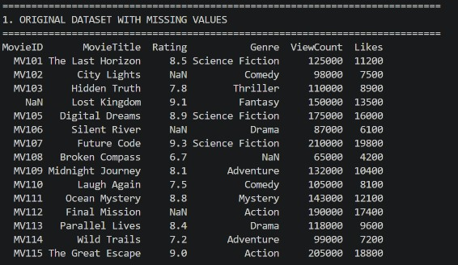  Figure 1.1 Original dataset printed after creating the DataFrame (containing missing values).  The average rating was calculated successfully and was used to replace all missing Rating values.  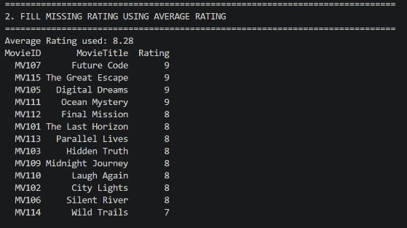  Figure 1.2 Output showing the calculated average rating.
Student Reg. No: 26MML0031 Name: Makada Hasnain H

Faculty: Dr Rajasekhara Babu M, Professor, School of CSE, Vellore Institute of Technology (VIT), Vellore
14 | P a g e

2025 WINTER SEMESTER
Programming for Data Science Lab (MACSE502) Record Exercise Program
Date: 16/07/2026 Week No.: 2 Program S. No. 4
Missing Rating values were replaced with the calculated average rating while preserving all other records.

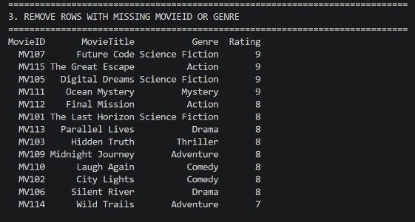
Figure 1.3 Dataset after fillna() operation.

Rating values were converted into integer type and normalized using the Min-Max Normalization technique.

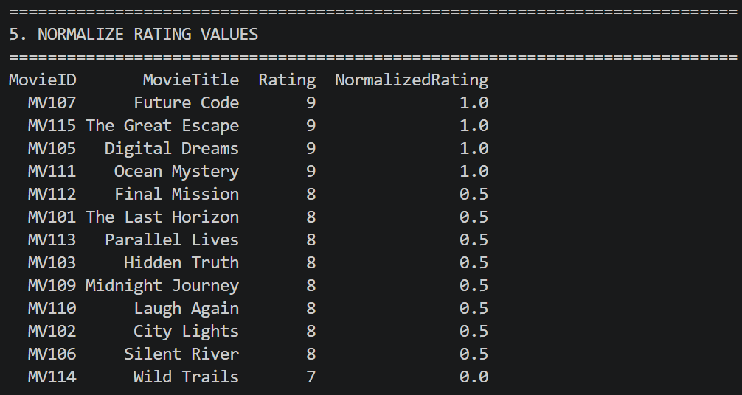
Figure 1.4 Integer Rating output along with the
NormalizedRating column.

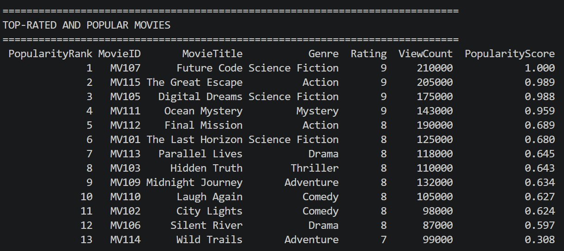
Figure 1.5 Sorted movie list showing Popularity Rank.

Movies were ranked successfully based on their popularity score, allowing easy identification of top-performing movies.
Conclusions | The Movie Rating Data Preprocessing project was successfully implemented using the Pandas library. The dataset was created with missing values, and the missing Rating values were replaced using the average rating. Records with missing MovieID or Genre were removed to improve data quality. The Rating column was converted into integer type, and the values were normalized using the Min-Max normalization  technique. The project also identified top-rated movies, generated genre-wise reports, analysed viewer preferences, recommended
Student Reg. No: 26MML0031 Name: Makada Hasnain H

Faculty: Dr Rajasekhara Babu M, Professor, School of CSE, Vellore Institute of Technology (VIT), Vellore
15 | P a g e

2025 WINTER SEMESTER
Programming for Data Science Lab (MACSE502) Record Exercise Program
Date: 16/07/2026 Week No.: 2 Program S. No. 4
 | movies based on genre and rating, and visualized movie popularity trends. This exercise provided practical knowledge of data preprocessing, data analysis, and dashboard development using Python, Pandas, and Streamlit.
References | - Michael Freeman and Joel Ross, Programming Skills for Data Science: Start Writing Code to Wrangle, Analyze, and Visualize Data with R, Addison-Wesley, 2018  - Python Program (https://github.com/hasnainmakada-99/Data-Science-Codes/blob/main/WEEK%202/EXERCISE_PROGRAM.py)  - Class lecture link https://drive.google.com/file/d/15diEukCtrPLimox63oa9ce1U-t4qVMUy/view

Student Reg. No: 26MML0031 Name: Makada Hasnain H

Faculty: Dr Rajasekhara Babu M, Professor, School of CSE, Vellore Institute of Technology (VIT), Vellore
16 | P a g e

